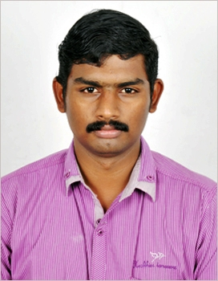**Rajeevan P R Mob: 08281201465 / 09500088165**

Puliyakkottu House, Email : [rajeevprmenon@gmail.com](mailto:rajeevprmenon@gmail.com) Vadavannur ( P O ), [rajeevan.ravi@yahoo.com](mailto:rajeevan.ravi@yahoo.com)

Palakkad ( Dist )

Pin - 678504

**OBJECTIVE**

* I am looking for the best career platform to perform where my technical knowledge and creative skills are exploit in the possible manner in a way benefited to the organization and providing me a creative fulfillment as well. I would like to be associated with an amiable atmosphere where career prosperity and growth are assured .

**EXPERIENCE**

* Working in **TIMES TELEVISION NETWORK** as **LOCAL FIELD SALES EXECUTIVE** from Apr 2015 to till date . Handling local sales and distribution of all the channels like Times Now , Movies Now etc.

* Worked in **VAIKHARI** as a **HEAD OF OPERATIONS - (PRODUCTION)** for **SOUBHAGYAVATHY (Surya TV)** Project from Oct 2013 to Dec 2014. Handling complete Production Front, coordinating with production and direction team for scheduling shooting dates, Preparing daily shoot report, sending daily expenses reports to Mumbai & Chennai office, Handling post production and sending the final masters to Chennai office .
* Worked as a **CO-ORDINATOR A&S (Aired times and Sales) OPERATIONS** television and **QC** for Fourteen programs in the **WALT DISNEY INDIA** company from 2012 to Sep 2013.
* Worked as an **EXECUTIVE A&S OPERATIONS** and **QC** for Fourteen programs in **UTV Software Communication LTD** from 2009 to 2012.
* Worked as an **ACCOUNTANT** under a registered **TAX practitioner** for one year ( 2008 – 2009 ) .

**QUALIFICATION**

* **B.Com** ( Calicut University March 2008 )
* **PLUS TWO** ( H.S.C March 2005 )
* **S.S.L.C** ( V.M.H.School , Vadavannur Kerala State Board March - 2003

**SOFTWARE KNOWN**

* Windows , PGDCA , DTP.

**INTEREST**

* Listening to Music , Gaming , Long Driving

**PERSONAL DETAILS**

* Name : Rajeevan P R
* Father Name : Raveendran M
* Religion : Hindu , Nair
* Date of Birth : 25-05-1988
* Sex : Male
* Nationality : Indian
* Marital Status : Single **Permanent Address** : **Puliyakkottu House  
   Vadavannur ( P O )  
   Palakkad ( Dist )  
   Pin – 678504.  
  REFERENCE**

Mr. Leelaram ( Business Head UTV Software Communications LTD ) Mob No. 09840967754 .

* **DECLARATION  
    
    
  I assured that the above furnished details are genuine and true to the best knowledge of mine. Any additional details will be furnished on request.**

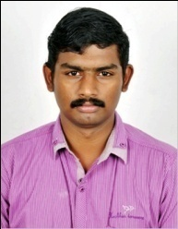

* **Place :Palakkad**
* **Date :**

**RAJEEVAN P R**